Rachel Wood ~ Figure Skating
(Coaching, Choreography & Artistry on ice)
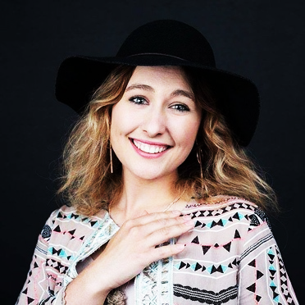
Contact | 0400124595 | rachelwoodfigureskating@gmail.com
Introduction
I began skating at the age of 8 and fell in love with the feeling of flying along the ice! Figure skating and performing has been my life and my passion is to help, encourage and inspire others to experience and enjoy this incredible sport.
I have been very lucky to have trained with some inspiring coaches over my career including Australian, International and World champions, and to perform in a wide range of shows, including local productions, TV shows, commercials and the local Disney on Ice pre shows.
I strongly encourage good sportsmanship from my students to all skaters, coaches and competitors across the sport and would like to create a fun and supportive team environment for my skaters.
Goals for my Students
I am very passionate about encouraging students to dream, set goals and make a plan to achieve their goals. I am also very passionate about correct technique and artistry, and will help and encourage my students to achieve their best.
Coaching Plan
At the start of the term I will meet with each student to discuss their goals and plans for the year and term. We will regularly review the student’s progress and goals.
Schedule
A weekly coaching schedule will be sent in advance each week via email to each student
Fees
On Ice Coaching: | $42 per 30 minutes. | ($1.40 per minute includes. GST and Ice Rink Coaches Fees)  Lessons can be shared by up to 3 skaters or couples.
Off Ice Coaching: | $21 per 15 minutes | ($1.40 per minute incl. GST and Ice Rink Coaches Fees) Lessons can be shared by up to 3 skaters or couples
Tests and Competitions: | $42 per test, event or practice
Music Preparation | $50 for a music edit/cuts | Music will be provided on a CD and as an MP3 file

Cancellations: You must give me 24 hours’ prior notice to avoid losing your lesson fee. I will endeavor to make up that lesson within the scheduled fortnight, time permitting. Please leave a phone or text message if you are unable to make your lesson. Repeated no shows will result in a loss of your lesson time.
Payment: Payment for lessons must be done via the front desk at iceHQ and proof of payment will be by handing me a receipt copy. No receipt, no lesson. I can only accept payment directly by cash for lessons away from iceHQ, attendance at tests and competitions and music preparation.
Career Highlights and Achievements:

- Australian Experience 2001 – present with local coaches and my current amazing coach Dorothy Bisset
- International Experience
- UK 2012 Karen Goodwin
- USA 2012 with World coach of the year Rafael Arutyunyan (Ashley Wagner’s coach)
- USA 2018 with Doug Murray who also works closely with Rafael Atrium, and Lorna Brown

- 3 times Victorian State Champion
- 2 times Australian National championships placing top 10 in intermediate ladies in 2011
- 3rd place at Hollins Trophy Challenge 2012 NSW national event in intermediate level
- 1st place in numerous state and national artistic competitions including Crystal Challenge 2011, and Winter Sun Queensland 2010.
- Victorian State Squad member 2011 and 2012
- Lead roles in OBGA Christmas shows some highlights including Marylyn Monroe, Alphaba, Ariel and Elsa from frozen in 2014 and most recently in 2018 the Tinman
- 2 times Disney On ice pre show lead performer
- Choreographed Disney on Ice pre show audition 2012
- Choreographed 2 Oakleigh Christmas show numbers in 2017
- Performed on Various TVs shows and in a TV Commercial

- Girlfriend Magazine of the year finalist in 2013 for skating

- Currently running my own Illustration/Design business “Rachel Belle Design” which features some unique figure skating illustrated products! www.rachelbelledesign.com.au

